ASSIGNMENT-14

**Lab 14: Web Design Application – AI-Assisted HTML/CSS/JS**

TASK-1

AI-Assisted Portfolio Website Scenario:

A student wants to showcase their projects, skills, and contact details in a portfolio website. Instead of writing all code manually, they want to speed up the process using GitHub Copilot.

* Use Copilot to generate an HTML structure for a personal portfolio page (sections: Home, About, Projects, Contact).
* Ask Copilot to suggest responsive CSS styling for the layout (e.g., grid/flexbox).
* Customize Copilot’s suggestions to add a hover effect on project cards.

PROMPT:

"Generate Python code that automatically creates a personal portfolio website. The Python program should:

* Create an index.html file with sections: Home, About, Projects, and Contact.
* Create a style.css file with responsive design using Flexbox or Grid layout.
* Add a hover effect on project cards.
* Use clean, modern, and responsive HTML/CSS structure.

The code should save both files in the current directory and print a confirmation message when done."

CODE:

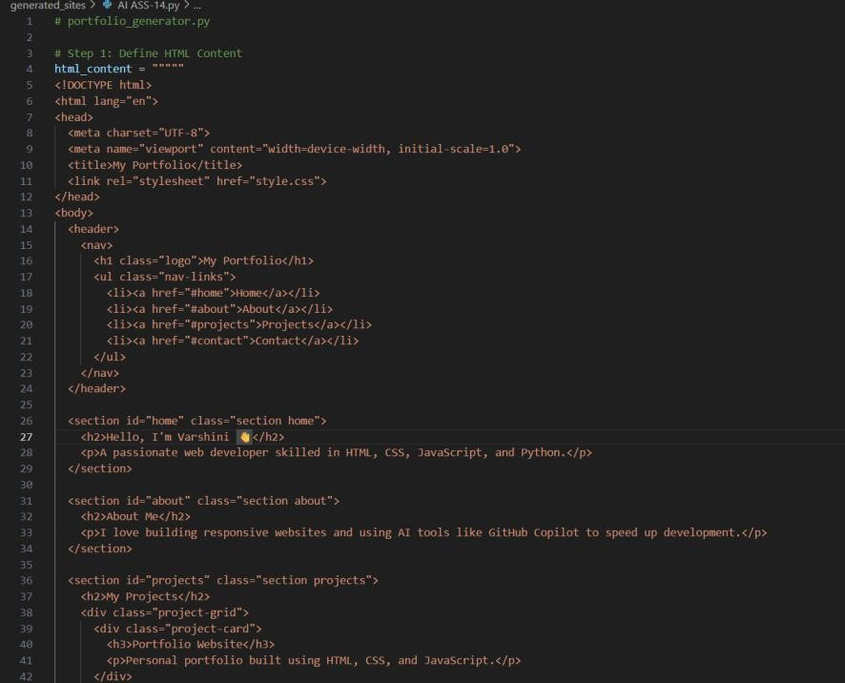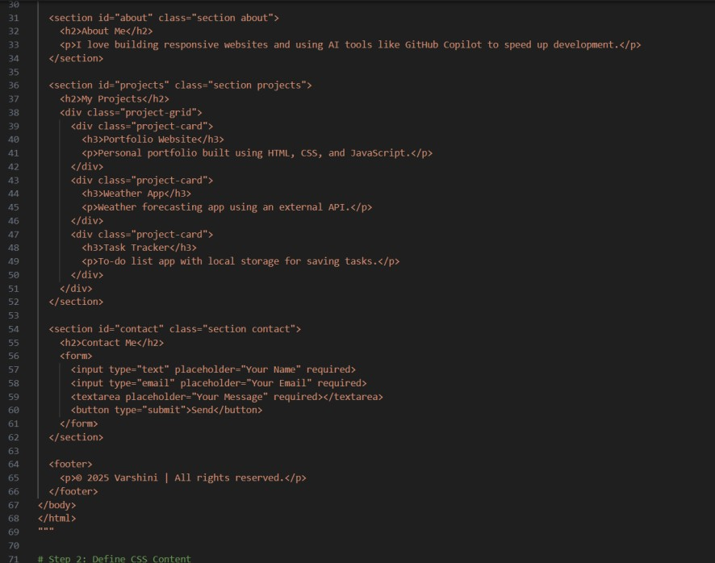

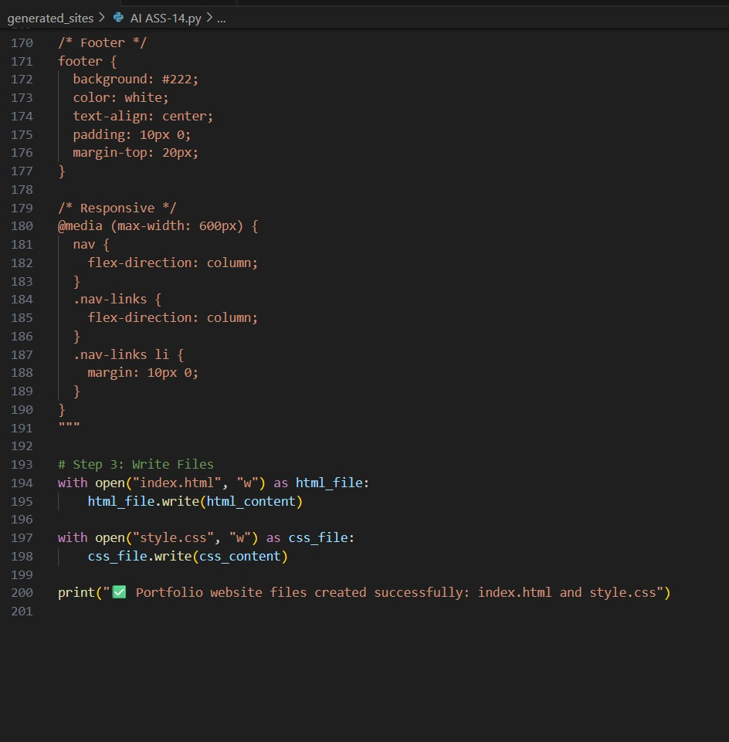

OUTPUT:

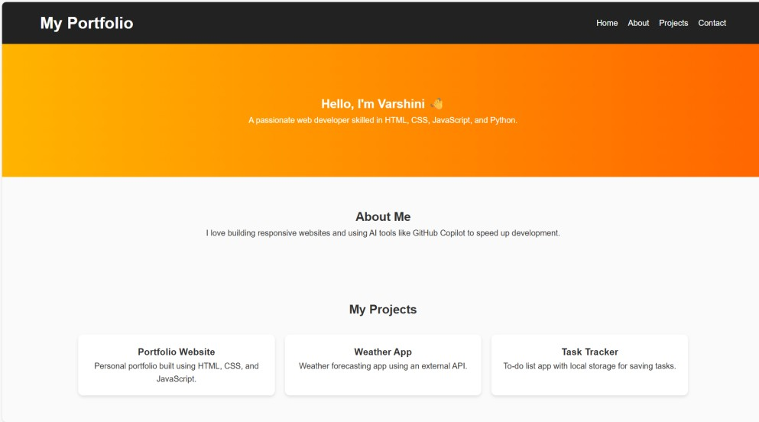

Files Used:

* index.html
* style.css
* script.js (optional)

TASK#2:

AI-Generated Restaurant Landing Page Scenario:

A local restaurant needs a simple landing page with a navigation bar, menu highlights, and an image gallery. The developer wants to quickly generate it using AI assistance.

* Use Copilot to create a navigation bar with links (Home, Menu, Gallery, Contact).
* Generate a menu section styled with CSS cards.
* Add a JavaScript-based image slider for the gallery, with Copilot suggesting the base code.

PROMPT

Generate a Python program that automatically creates a restaurant landing page.

The program should:

Create an index.html file with sections: **Home**, **Menu**, **Gallery**, and **Contact**.

Add a **navigation bar** with links to each section.

Design the **menu section** using **responsive CSS cards** for food items.

Add a **JavaScript image slider** for the gallery section that shows multiple food images with next/previous buttons.

Use clean, responsive **HTML**, **CSS**, and **JavaScript** code.

Save the generated files (index.html, style.css, script.js) in the current directory and print a success message after creation

CODE:

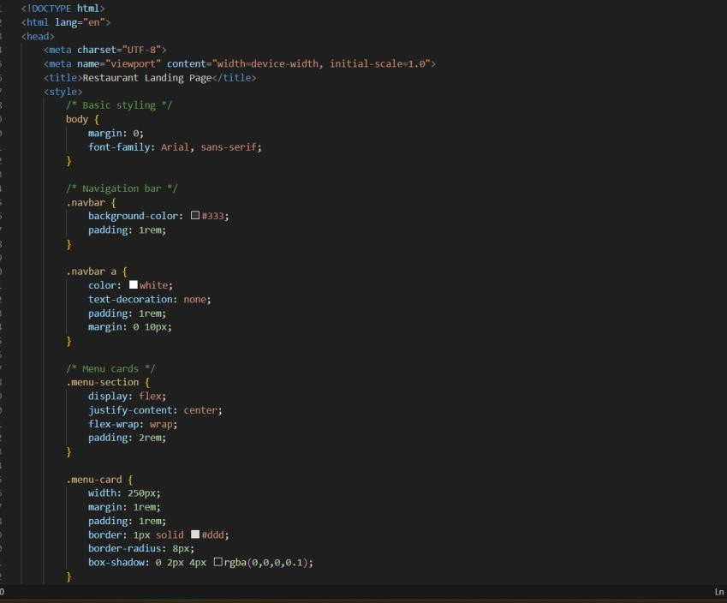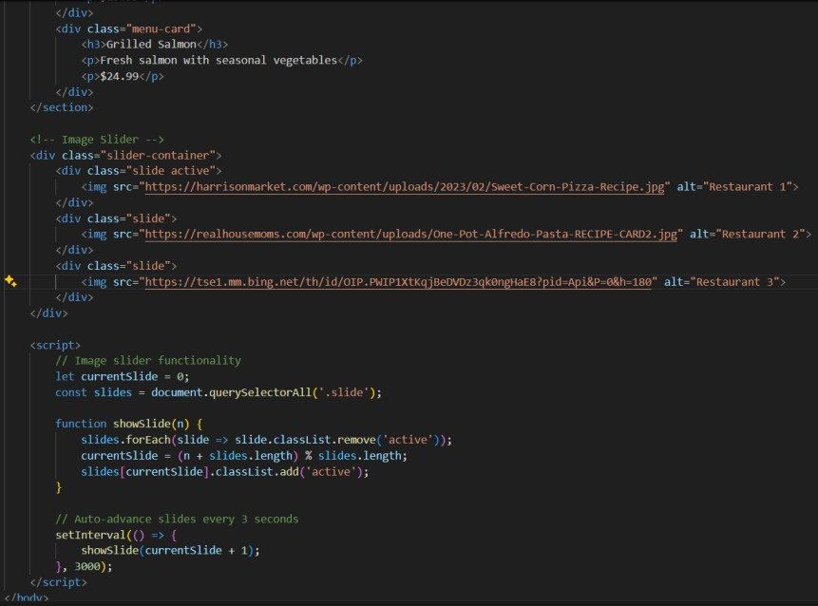

OUTPUT:

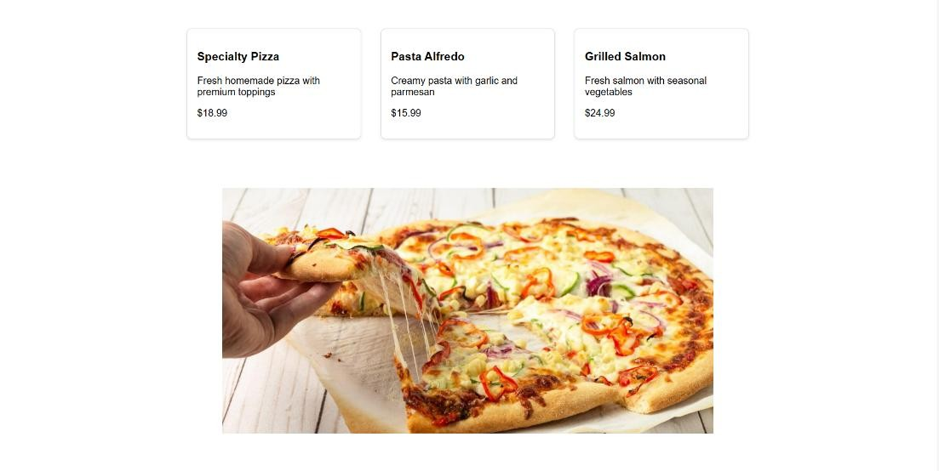

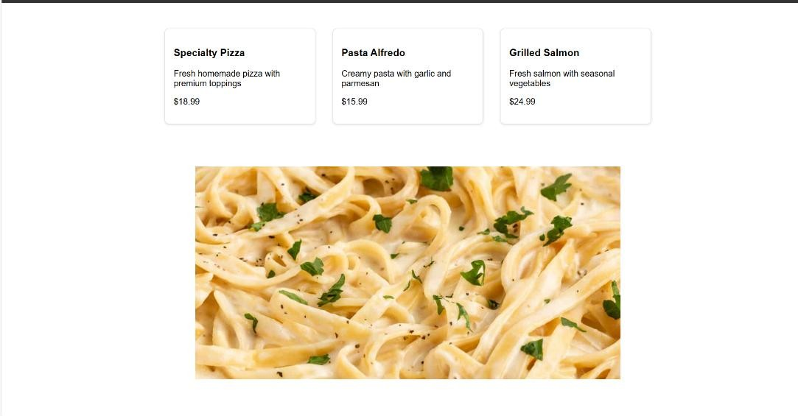

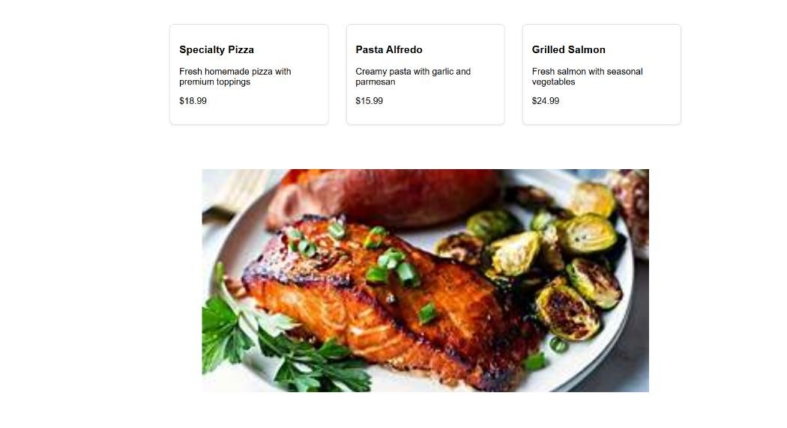

TASK-3:

AI-Powered Event Registration Form Scenario:

SR University is hosting a tech fest. They need a web-based registration form for students. The form must validate user input in real-time. • Ask Copilot to generate an HTML form (fields: Name, Email, Phone, Department, Event Selection).

* Use Copilot to assist in adding CSS styling for an attractive form layout.
* Implement JavaScript validation (e.g., email format check, phone number length check) using Copilot’s suggestions.

PROMPT:

* Create an index.html file with a registration form containing the following fields: **Name**, **Email**, **Phone**, **Department**, and **Event Selection (dropdown)**.
* Create a style.css file with modern, responsive styling for the form (centered layout, input box styling, and hover/submit button effects).
* Create a script.js file with **JavaScript-based real-time validation** for:
  + Checking **email format**
  + Ensuring **phone number has exactly 10 digits** o Making sure all fields are filled before submission
* Display appropriate **error messages** near invalid fields.
* Save all three files (index.html, style.css, script.js) in the current directory and print a message like “Event Registration Form Created Successfully.”

CODE:

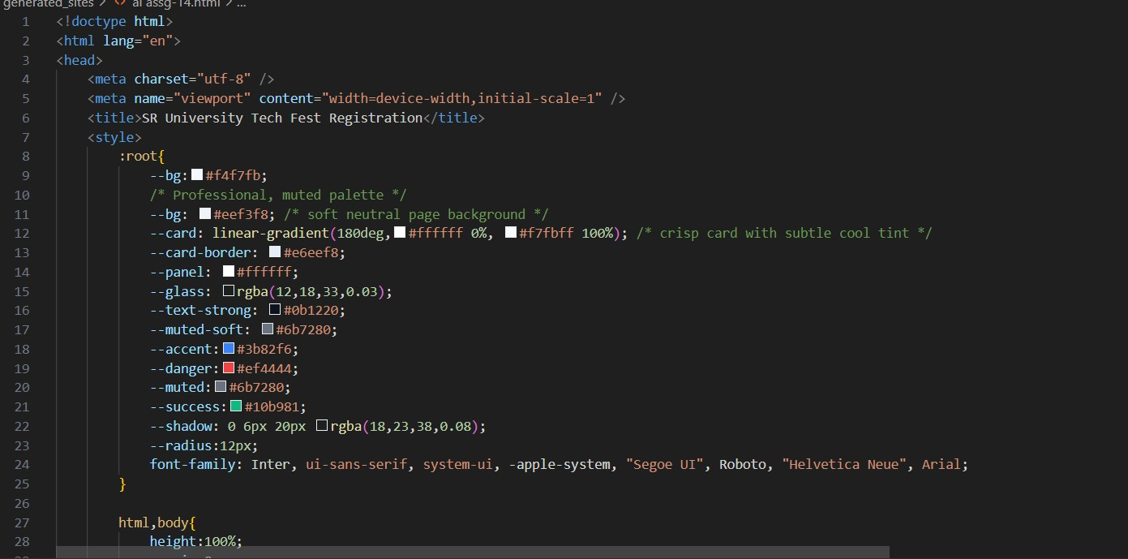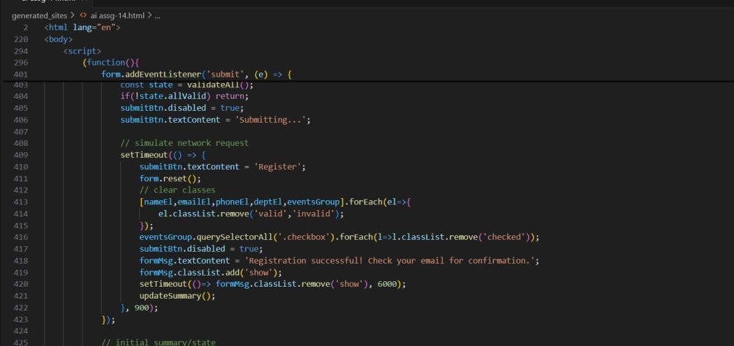

OUTPUT:

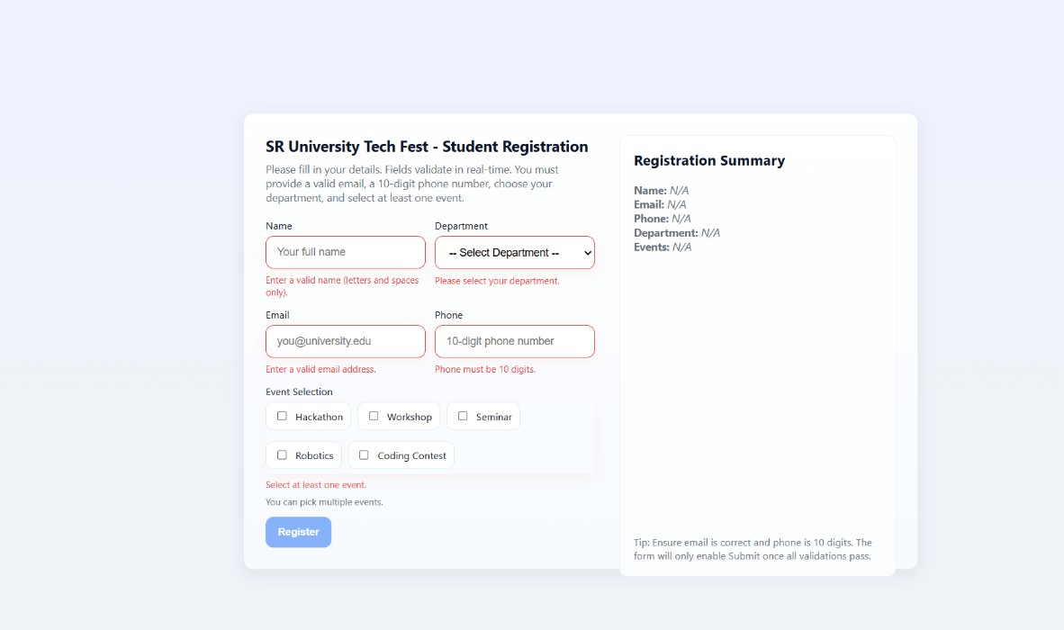

TASK4:

A startup wants a basic e-commerce product page to display products with prices and an “Add to Cart” button.

* Use Copilot to generate a grid-based product catalog in HTML/CSS.
* Implement a JavaScript “Add to Cart” functionality with Copilot’s guidance.
* Modify Copilot’s suggestions to include a cart counter at the top-right corner of the page.

PROMPT:

* A **grid-based product catalog** displaying multiple products with their **names, images, prices, and “Add to Cart” buttons**.
* A **cart counter icon** at the top-right corner that updates dynamically whenever a user clicks “Add to Cart.”
* Use **responsive CSS (Flexbox or Grid)** to make the layout look good on both desktop and mobile screens.
* Use **JavaScript** to implement “Add to Cart” functionality and update the cart counter in real time.
* Style the page with **modern, attractive colors, rounded product cards, and hover effects** on buttons.
* The project should include three files — index.html, style.css, and script.js.

CODE:

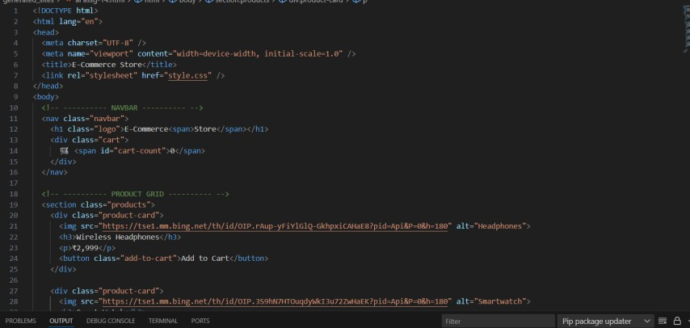

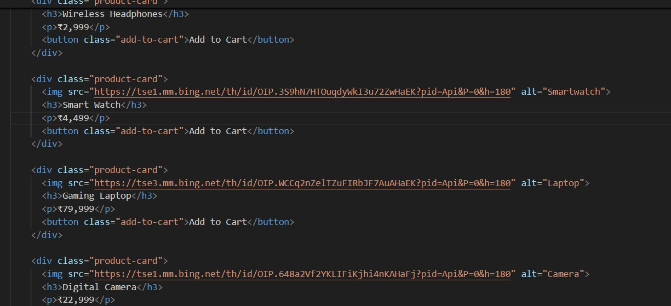

OUTPUT:

